1. **INTRODUCTION**
2. Measuring success in talent management typically involves tracking various key performance indicators (KPIs) such as employee retention rates, time-to-hire, employee satisfaction scores, and overall workforce productivity. It's also essential to assess the impact of talent management strategies on organizational goals, including factors like revenue growth, innovation, and market competitiveness. By analyzing these metrics, businesses can effectively evaluate the effectiveness of their talent management practices and make informed decisions to optimize their workforce.

1. Measuring success in the context of talent often involves assessing factors such as kill acquisition, goal achievement, professional growth, and the ability to contribute meaningfully to the organization. It’s important to establish clear, quantifiable metrics aligned with the individual’s and the organization’s objectives to effectively gauge success. Regular performance evaluations, feedback mechanisms, and tracking key performance evaluations, feedback mechanisms, and tracking key performance indicators are valuable tools in this process.
2. **Problem definition & design thinking**

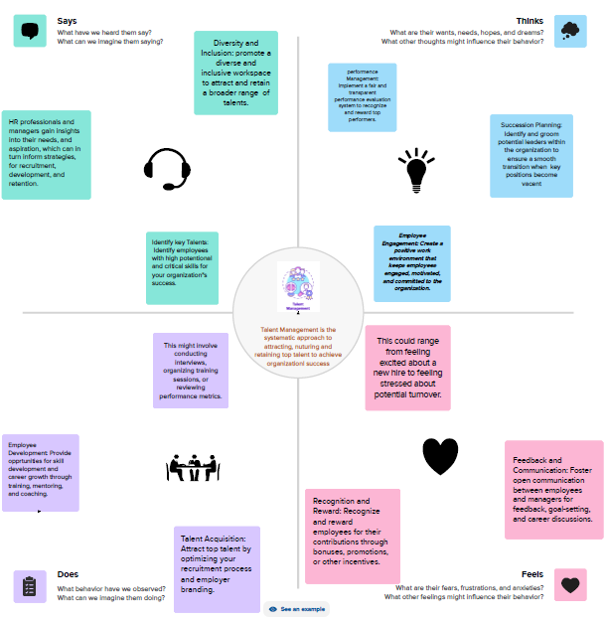

**Brain stroming**

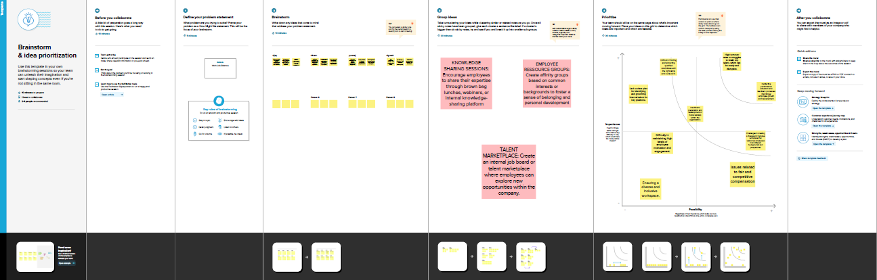

1. **RESULT**
2. Dashboard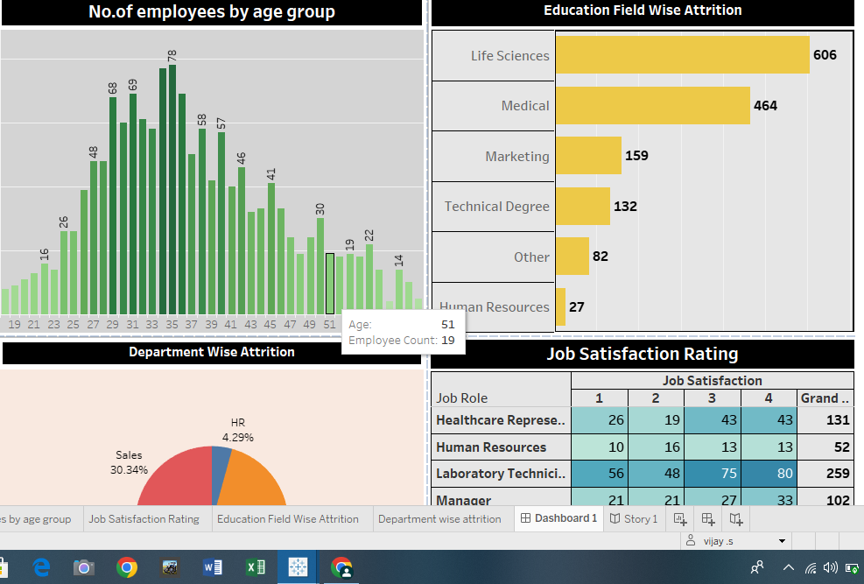

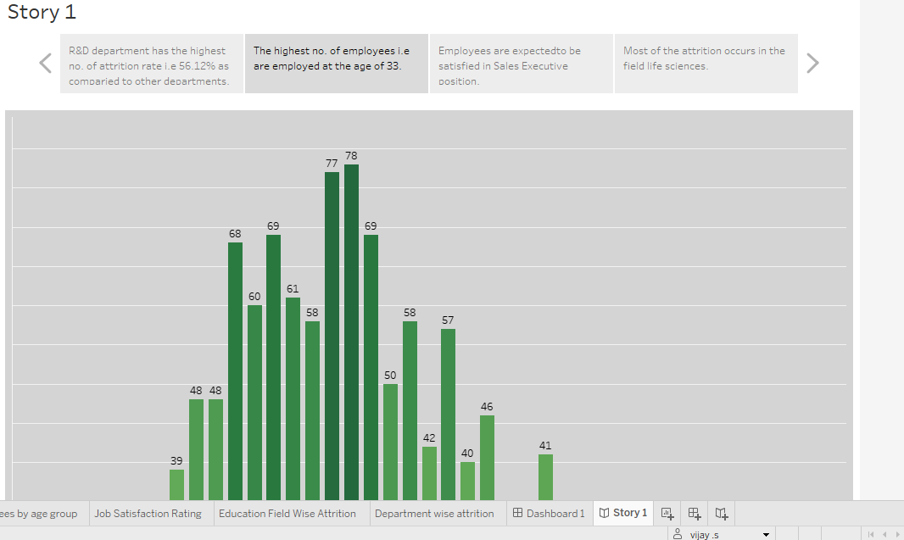

1. Advantage & disadvantage

Advantage

Facilitating data-driven desicisionmaking, ensuring that companies can objectively identify high-performing employees, allocate resources effectively, and implement targeted strategies for talent development. This data-driven approach enables organization to align their talent management practives with their overarching business goals, ultimately fostering a more productive and engaged workforce.

Disadvantage

One major disadvantage of measuring success in talent management is the potential for fostering a competitive rather than collaborative work environment, leading to an unhealthy atmos [here among employees.

1. **Applications**

Monitoring retention rates and conducting exit interviews can help companies understand whether their talent management intiatives are effectively retaining top talent. Tracking the progress of employee’s skill development through training programs and workshops can help assess the effectiveness of talent development efforts.

1. **Future scope**

Measuring success in talent management in the future will likely involve a comprehensive analysis of various metrics such as employee engagement, retention rates, skills development, and diversity inclusion. With the integration of advanced technologies, predictive analytics, and AI, organizations will be able to assess performance more accurately and efficiently, thereby enabling better strategiv decision-making and the identification of potential future leaders.